National Media Manipulating Cultural Identity
EMS3M1
Media is a key tool in manipulating how we view ourselves as individuals and as a nation. A uniform Canadian identity is hard to pin down, so the government often uses media to try to remind or simply tell Canadians who they want us to feel we were and are, should and could be. Hidden here is the requirement to use the second, essay-style template from the class website for this submission. If your submission is missing elements from the essay format template, for example, automatic page numbering, a significant number of marks will be heartlessly deducted. Likewise, marks will be coldly deducted for mentioning yourself, or for saying “you” or “your” in the submission. Your introductory paragraph will simply inform your reader of the existance of HIstorica Canada’s Heritage Minutes series, with some fun Wikipedia’ed facts in there to get the ball rolling.

Effect Achieved Section
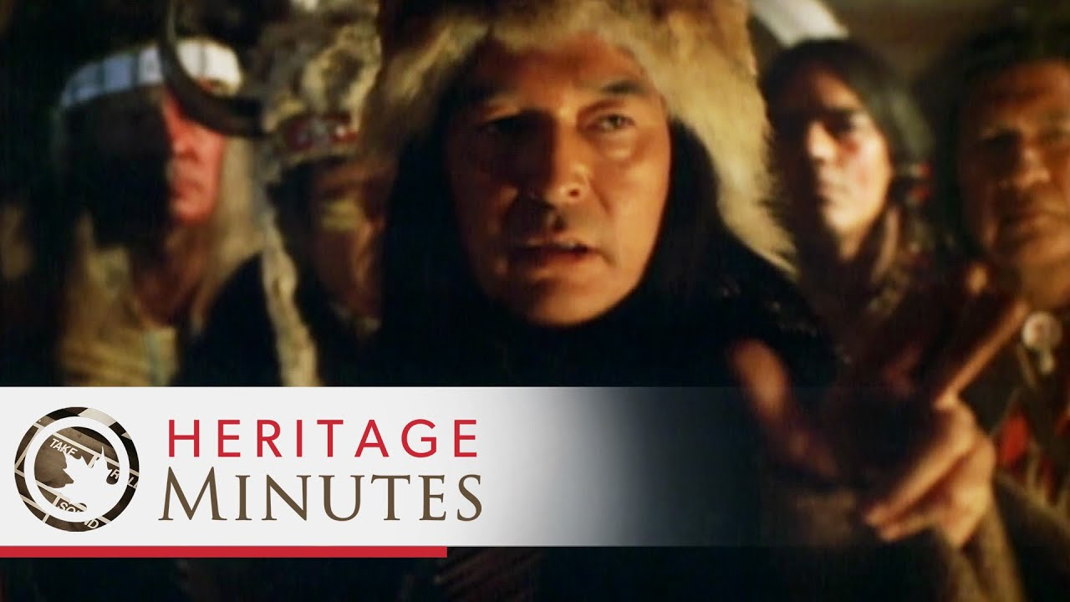
Watch a large number of Historica Canada’s Heritage Minutes/Moments. Note that three is not a large number. At all. Look for commonalities in what thoughts, feelings, ideas and perspectives the group of these media texts is trying to instill and elicit. (Use the words “instill” and “elicit” correctly.)
Identify (1) who the intended audience seems to be, and (2) what the body of media texts is trying to do to their thoughts, feelings and world view.
For example, you could, quite erroneously, conclude that these film shorts are mainly trying to make Australians feel ashamed of the quality of their national cheese industry. You could, just as erroneously, conclude that these film shorts are mainly trying to impress upon Minnesotans the necessity of sorting their recycling properly and make them feel proud to be dutiful recyclers.
Rather than simply talking about yourself and how you felt watching these, write further paragraphs talking about what responses this group of tax-funded, nationally broadcast film shorts are apparently trying to elicit. Use www.imdb.com for names.
Before moving on to the section below, ensure that you do a paragraph referencing specific episodes by name, as to their intended effect. The correct format for discussing these media texts uses capitals, italics, and quotation marks like this: Historica Canada’s Heritage Minutes episode “Jacques Plante.” Failure to demonstrate an ability to adhere to this convention will result in more tragically lost marks.

Strategies For Achieving It Section
With specific reference, by Heritage Minute episode name, using quotation marks and italics correctly, outline how various of them are constructed in order to influence the viewer in the desired way. Think of what specifically the narrator says (and how), what the actors do and say and emote, what the music does, what images are shown, what is done with sound design, and anything else you can see being done. Don’t use “you” or “your,” don’t mention yourself, and don’t speak in generalities. Dissect these things thoroughly and use a lot of specifics. Use www.imdb.com for names or further marks will be dutifully deducted. Shoot for a writing style as concise (fewer words, more ideas) and coldly analytical as the one used in this assignment sheet.

